### 

### Semester One Examination, 2020

### Question/Answer booklet

# MATHEMATICS METHODS

**UNIT 3**

## Section One:

## Calculator-free

|  |  |
| --- | --- |
| **Your Name:** |  |
| **Your Teacher’s Name:** |  |

## Time allowed for this section

Reading time before commencing work: five minutes

Working time: fifty minutes

## Materials required/recommended for this section

***To be provided by the supervisor***

This Question/Answer booklet

Formula sheet

***To be provided by the candidate***

Standard items: pens (blue/black preferred), pencils (including coloured), sharpener, correction fluid/tape, eraser, ruler, highlighters

Special items: nil

## Important note to candidates

No other items may be taken into the examination room. It is **your** responsibility to ensure that you do not have any unauthorised material. If you have any unauthorised material with you, hand it to the supervisor **before** reading any further.

|  |  |  |  |  |  |
| --- | --- | --- | --- | --- | --- |
| Question | Marks | Max | Question | Mark | Max |
| 1 |  | 5 | 5 |  | 8 |
| 2 |  | 7 | 6 |  | 10 |
| 3 |  | 7 | 7 |  | 6 |
| 4 |  | 5 |  |  |  |

**Structure of this paper**

|  |  |  |  |  |  |
| --- | --- | --- | --- | --- | --- |
| Section | Number of questions available | Number of questions to be answered | Working time (minutes) | Marks available | Percentage of examination |
| Section One:  Calculator-free | 7 | 7 | 50 | 48 | 34 |
| Section Two:  Calculator-assumed | 12 | 12 | 100 | 93 | 66 |
|  |  |  |  | **Total** | 100 |

**Instructions to candidates**

1. The rules for the conduct of the Western Australian Certificate of Education ATAR course examinations are detailed in the *Year 12 Information Handbook 2019*. Sitting this examination implies that you agree to abide by these rules.
2. Write your answers in this Question/Answer booklet.
3. You must be careful to confine your answers to the specific questions asked and to follow any instructions that are specific to a particular question.
4. Additional pages for the use of planning your answer to a question or continuing your answer to a question have been provided at the end of this Question/Answer booklet. If you use the space to continue an answer, indicate in the original answer space where the answer is continued, i.e. give the page number.
5. **Show all your working clearly.**Your working should be in sufficient detail to allow your answers to be checked readily and for marks to be awarded for reasoning. Incorrect answers given without supporting reasoning cannot be allocated any marks. For any question or part question worth more than two marks, valid working or justification is required to receive full marks. If you repeat any question, ensure that you cancel the answer you do not wish to have marked.
6. It is recommended that you **do not use pencil**, except in diagrams.
7. The Formula sheet is **not** to be handed in with your Question/Answer booklet.

**Section One: Calculator-free (48 Marks)**

This section has **seven** questions. Answer **all** questions. Write your answers in the spaces provided.

Spare pages are included at the end of this booklet. They can be used for planning your responses and/or as additional space if required to continue an answer.

● Planning: If you use the spare pages for planning, indicate this clearly at the top of the page.

● Continuing an answer: If you need to use the space to continue an answer, indicate in the original answer space where the answer is continued, i.e. give the page number. Fill in the number of the question that you are continuing to answer at the top of the page.

Working time: 50 minutes.

**Question 1 (5 marks)**

Jamie and Catherine are racing on roller skates. They race along a long, straight track, and whoever has gone the farthest after 5 seconds wins a prize.

If Jamie can skate at a velocity of $f\left(t\right)=5+2t$ m/s and Catherine can skate at a velocity of   m/sec, who is going to win the race? Justify.

**Question 2 (7 marks)**

Suppose that $f\left(x\right)$ and $g\left(x\right)$ are diﬀerentiable functions and that $h\left(x\right)=f\left(x\right)g\left(x\right)$. You are given the following table of values.

|  |  |
| --- | --- |
| $$x$$ | $$-1$$ |
| $$h\left(x\right)$$ | $$-9$$ |
| $$g\left(x\right)$$ | $$9$$ |
| $$f^{'}\left(x\right)$$ | $$-2$$ |
| $$h^{'}\left(x\right)$$ | $$-20$$ |

1. Determine the value for $f\left(-1\right)$ and hence determine  when . (3 marks)
2. Determine the value for when . (2 marks)
3. Determine the value for $T^{'}\left(-1\right)$, given that $T\left(x\right)=f\left(f\left(x\right)\right)$. (2 marks)

**Question 3 (7 marks)**

The diagram below shows the curve $y={\left(3-2x\right)}^{3}$ and the tangent line to the curve at $\left(\frac{1}{2},8\right).$

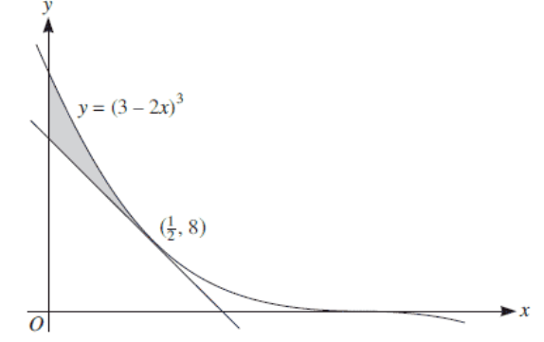

1. Find the equation of this tangent, giving your answer in the form $y= mx + c$.

(3 marks)

1. Find the area of the shaded region. (4 marks)

**Question 4 (5 marks)**

The total cost, $ to manufacture  items at a factory is given by the rule $C={\left(2x+16\right)}^{3}$.

Determine the minimum value of the **average cost per unit**. Justify.

**Question 5 (8 marks)**

1. Consider a cubic polynomial $y=Ax^{3}+6x^{2}-Bx$, where $A$ and $B$ are unknown constants. Determine the values of $A$ and $B,$ so that the graph of $y$ has a maximum value at $x= -1$ and an inflection point at $x=1$. (4 marks)
2. Find the point $\left(x,y\right)$ on the graph of  where the tangent line is perpendicular to the line $4x+y = 1$. (4 marks)

**Question 6 (10 marks)**

A discrete random variable $X$ has the probability function

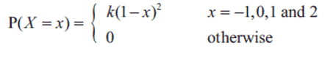

1. Show that $k = \frac{1}{6}$ (3 marks)
2. Find $E(X).$ (2 marks)
3. Show that $E(X^{2})=\frac{4}{3}$ (2 marks)
4. Find $Var(1-3X)$ (3 marks)

**Question 7 (6 marks)**

Let $f\left(x\right)$ be a non-zero function such that $f^{'}\left(x\right)={\left[f\left(x\right)\right]}^{2}$.

1. Determine an expression for $\frac{d}{dx} \frac{1}{f\left(x\right)}$. (3 marks)
2. Determine an expression for $f(x)$ using the result from (a), or otherwise, given $f\left(0\right)=\frac{1}{2}$. (3 marks)

Additional working space

Question number: ________

Additional working space

Question number: ________